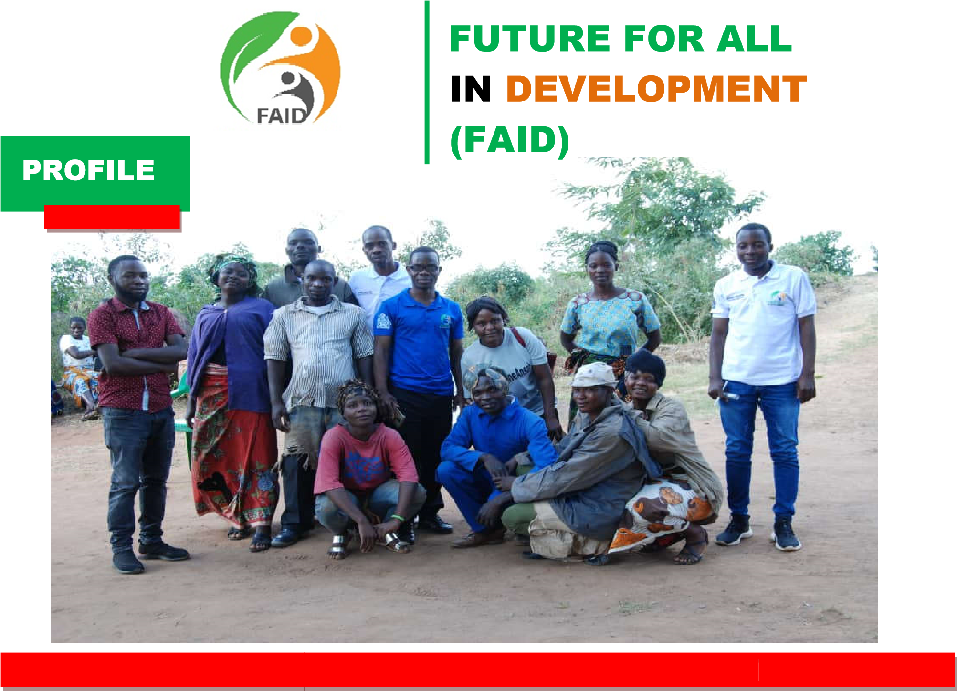

|  |  |  |  |
| --- | --- | --- | --- |
|  | |  |  | | --- | --- | | Along B  C/O D  P.O. Bo **Mobile:**  **Email:**f | lantyre – Chikwawa Road  ulansanje Primary School  x 37, Chikwawa, Malawi  +265881070034/ +265993671006 utureforallindevelopment@yahoo.com | |

# About us

Future for All in Development (FAID) is a local nonprofit making organization that was established in July, 2015 and legally registered in April, 2021 under the Trustees Incorporation Act, with an aim of promoting food security self-reliance and improved livelihood at household level and beyond. FAID is geared to work with partners having common interests in its thematic areas of Education, Agriculture, Climate change, gender and livelihood.

**Vision**  To become champion organization

For the achievement of socio – economic

development for all

nation – wide

|  |  |
| --- | --- |
|  | **To acts as a bridge that**  **Fills the gap to society’s socio – economic** |
| **Mission** | **Development by providing assistance**  **that ensures equal access to quality education, food security, environmental sustainability and gender equality** |

# Core values

• Solidarity

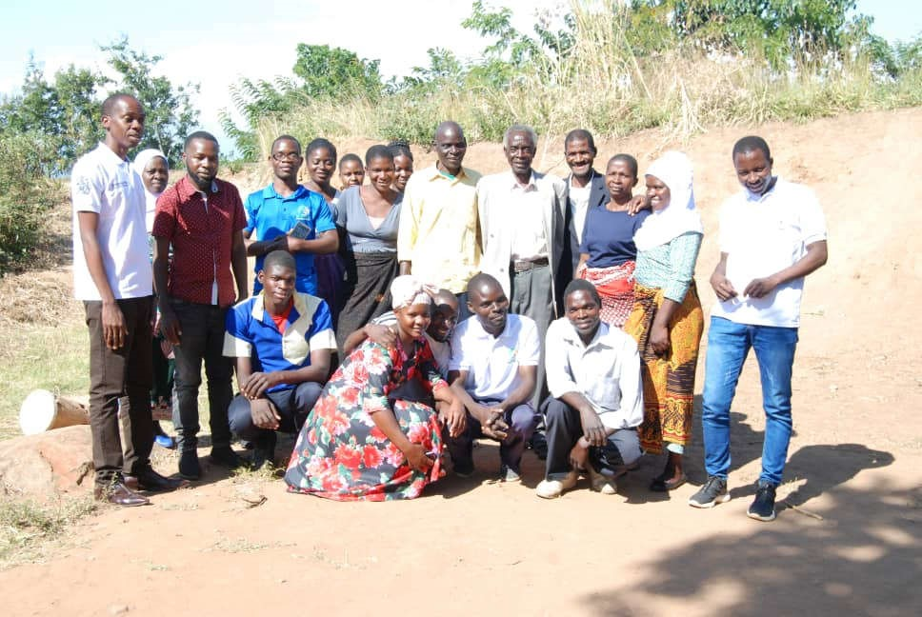

•

Integrity

•

Competency

**Focus**

FAID focuses on expanding access to

**Area**

cost

–

effective

opportunities that directly impact

livelihood of communities and

are directly linked to

sectors of agriculture, education, livelihood,

Gender and environment through efficient, participatory,

Inclusive, strategic and scalable approaches

## a. Agriculture

FAID’s aim is to ensure that smallholder farmers have access to modern farming technologies that are cost effective, user friendly and climatically smart. FAID promotes use of clean energy in crop production, use of drought resistant crops and technologies that optimize of of space or land for increased crop productivity and income per unit area.

## b. Environment and Climate change

FAID aims at enhancing the capacity of communities to utilize interventions that are safe, environmentally friendly and sustainably significant contributing to climate change adaptation and mitigation. FAID believes in interventions that when applied impact the communities. We engage emerging entrepreneurs, innovators with products to build and scale assistance and help them access the required resources.

## c. Education

FAID aims at promoting access to quality education for all at community. District and national levels. To achieve this FAID shall be providing school fees bursaries to the needy in its efforts to curb illiteracy levels in Malawi. Availability of funds shall determine its jurisdiction or beneficiaries for the common good of Malawian citizens.

## d. Livelihood

FAID aims at improving the livelihood of rural communities by enhancing enterprises that empower women, youth and vulnerable groups to pioneer vocational skills like tailoring, construction and metal works to achieve economic development among the rural masses.

|  |
| --- |
| **Our Current Project** |

FAID is currently working on a Project aimed at

youth

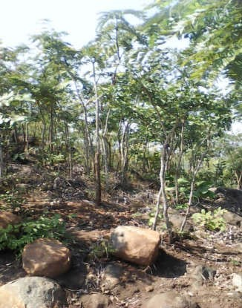

improving the livelihood of people through environmental conservation and management and and women empowerment covering tailoring.

**Our Staff** FAID has 5 Board of Trustees

(2 females, 3 males). The organization has currently

Filled the post of Executive Director,

Human Resources Manager, Finance Manager,

Monitoring and evaluation Manager,

Programme Manager and Project officers

**Source of Funding**

FAID mobilizes resources for project implementation through proposal developments and grants applications. The major sources of funding include institutional donors, individual donors, private sector, government, local resource levering and leveraging partnerships.